DEPARTMENT OF FILM & TELEVISION STUDIES
OPTIONS IN FILM STUDIES 2015/16

FI 102: HOLLYWOOD CINEMA
Module Tutors: Ed Gallafent (Autumn) and James MacDowell (Spring)

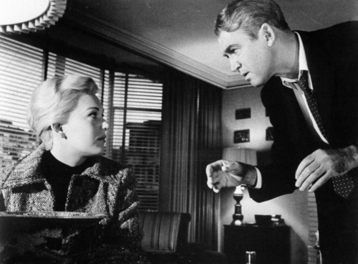
Vertigo (1958)

When we think of narrative film, it is not unusual to have the products of Hollywood in mind as a model of what film storytelling is like. Yet, as with any kind of filmmaking, ‘Hollywood cinema’ is not a singular proposition, but refers to an industrial and aesthetic tradition with a long and varied history. This module will offer a chance to engage in depth with some of the distinguished works produced by that tradition, and will provide several interlinking ways of understanding their meanings and significance.

Obviously it is impossible to do justice to more than a few examples of the kinds of achievement Hollywood cinema offers, so we will be looking at exemplary cases: genres, stars, directors, and issues such as the shifts brought about by changes in censorship and developments in technology. The module will pay close attention to the detailed analysis of the films screened, with the project of developing your skills in the reading of mise-en-scène and the resulting understanding of how meaning is produced on the screen. It will draw its case studies from the whole historical range of Hollywood sound production, from the 1930s to the present day. It will also look at Hollywood as a form of national cinema, examining the ways in which it has responded to broader issues in American society in the 20th and 21st centuries.

This module is a core module for students on the Film Studies degrees. As an option it is normally only open to students who have already successfully completed the Introduction to Film Studies module, FI 101.

Assessment :

The module is examined by two 3,000 word essays, one covering the Autumn Term work and one the Spring Term work . The essays count for 25% each of the final mark.

The examination is a seen examination (ie taken under usual exam conditions, but emailed to you around 15 days earlier). It is a two hour paper, in which you will choose one question to prepare and answer.. This can draw on the films screened in either term, or on a combination of the two, and counts for 50% of the final mark.

Screenings:

The module consists of a screening of a film or films (up to 3 hours in total) every week, plus one lecture and one seminar. In order to take this module, you must be available for both the Wednesday morning screening slot, and the lecture slot on Thursday morning. You will also need to be able to attend ONE of the seminars at the hours listed below. If your other modules clash with the lecture, you may not register for Hollywood cinema on the basis of recording the lectures, or borrowing lecture notes from other students.

Reading of selected critical and theoretical texts will be expected each week. The module will be taught in the Autumn and Spring terms, with revision meetings in the Summer Term. The timetable is as below.

If you wish to take this module you must register your application (after consultation with your department) with Tracey McVey in The Department of Film and Television Studies, Room A0.13 Millburn House, or via email: T.A.McVey@warwick.ac.uk

Timetable:

Wednesdays 9.00 – 12.00 Film Screening A0.28

Thursdays 10.00 – 11.00 Lecture A0.28

Thursdays
11 – 12 am )
12 – 1pm )
1 - 2 pm )
2 - 3 pm ) Seminars A1.24
3 - 4 pm ) A1.28

Vacation Reading

The Hollywood section of John Hill and Pamela Church Gibson (eds) The Oxford Guide to Film Studies (OUP) provides a good introduction. Richard Maltby’s Hollywood Cinema, an Introduction (Blackwell) is also extremely useful. A further list of provisional screenings etc. for the Autumn term will be issued in due course to those signed up for the module.

JM, EG April 2015

