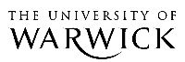

The History Seminar Week 3
Tuesday 16 October, 1pm-2.30pm

‘Geopolitics and Capitalism: Recasting the Origins and Development of the European System of States’

Benno Teschke, University of Sussex

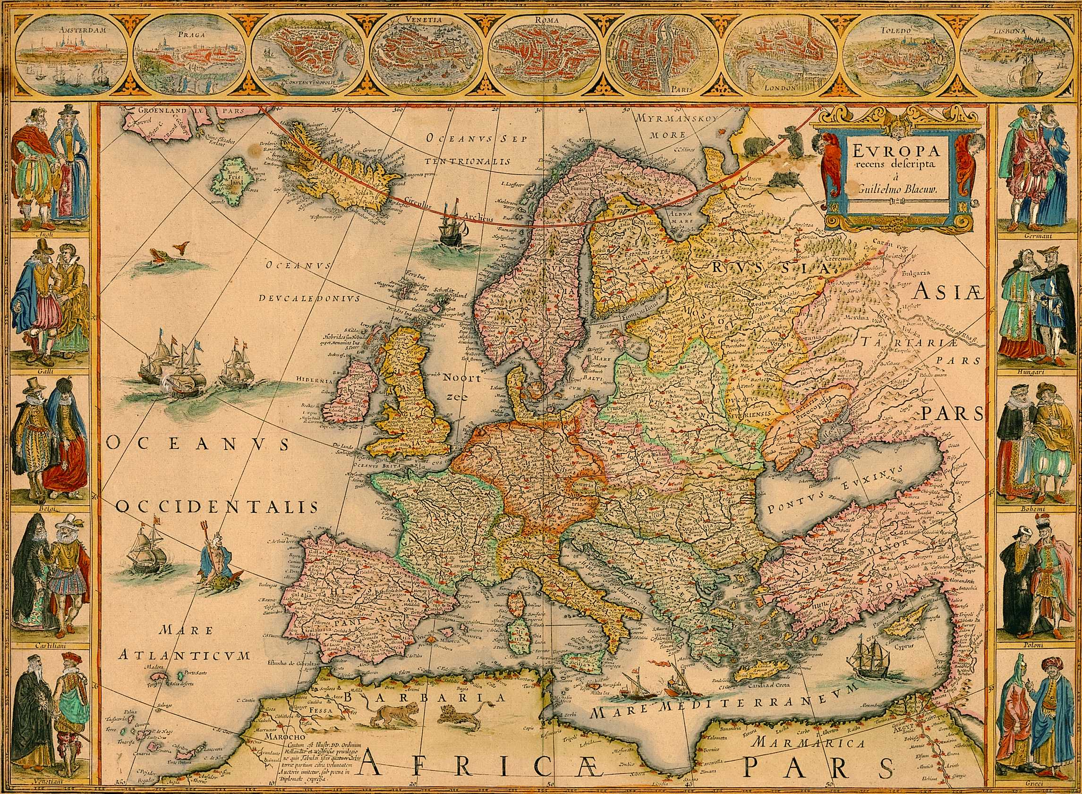
R1.13, Ramphal Building. Light refreshments will be provided.

