CENTRE FOR THE HISTORY OF MEDICINE
SEMINAR SERIES 2013-2014
Tuesday 29 April 2014 (Week 2)
5.30pm in Ramphal Building Room R0.14. All welcome.
Please note that the start time is slightly later than usual.
Prof. Bertrand Taithe (University of Manchester)
Prolonged emergencies and the development of humanitarian epistemic communities: the Thai border camps, c. 1976-1996
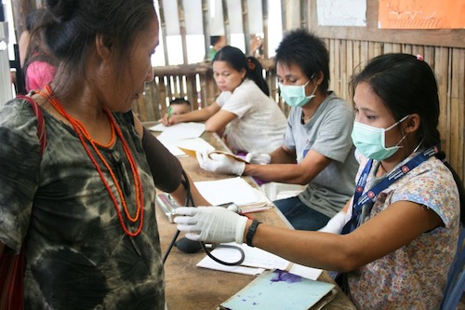
Photo: Malteser International
This paper considers the role of refugee camps on the Thai Border in the shaping of humanitarian practices and sciences. In particular this paper focuses on the 'experimental' research which took place in and around refugee camps over the period. This preliminary research asks what 'epistemic' communities emerged and how they adopted and challenged previous humanitarian practice.
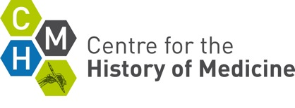 | Centre for the History of Medicine  The University of Warwick  Coventry CV4 7AL  Tel: 024 7657 2601  Email: hist.med@warwick.ac.uk

