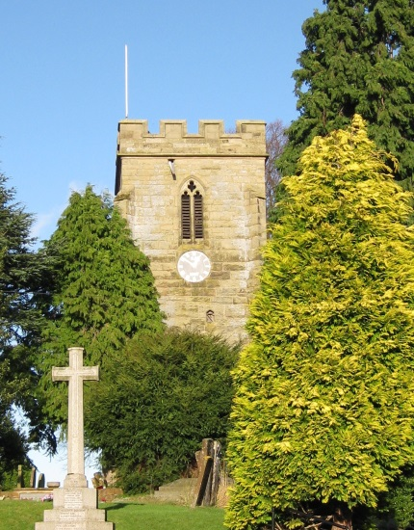

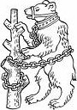 WLHS

Thirteenth Warwick Symposium on Parish Research, 16 May 2015

‘Warwickshire Parishes: History and Legacies’

10.30–11.00 Registration & coffee (Humanities, Ground Floor, in/near room H0.60)

11.00–11.15 Beat Kümin, Warwick: Introduction (all sessions in H0.52, Ground Floor)

11.15–12.15 Robert Swanson, Birmingham:
‘Little Local Difficulties: Parochial Problems in Pre-Reformation Warwickshire’

12.30–13.30 Lunch (Humanities Corridor, Ground Floor, near room H0.60)

13.30–15.00 Parish Project Presentations

- Kristi Bain, Norwich: ‘The Medieval Churches of Norwich research project’
- Patricia Cox, Chester: ‘Chester Consistory Records Project’
- Trevor England, Solihull Local History Circle: ‘Solihull town centre photographs c. 1900’
- Andrew Foster, Kent: ‘The Churchwardens’ Accounts Database’
- David Freke, Kineton & District Local History Group: ‘Local Memorials’
- Brenda Murray & Jill Tompkins Bailey: ‘Spirit of Berkswell’ project
- David Paterson, Nuneaton: ‘Chilvers Coton and Astley: How far were their schools parish institutions?’
- Andrew Thomson, Winchester: ‘Warwickshire Activities of the Consistory Courts of Worcester’

15.00–15.30 Tea (Humanities Corridor, Ground Floor)

15.30–16.45 - Ruth Barbour, Warwick / Warwickshire Local History Society:
‘Church Memorial Tablets: Reflections of Secular Power?
Memorials to Catholics in Warwickshire Parish Churches’
- Maureen Harris, Leicester / Warwickshire Local History Society:
‘“The malice and envy of my parishioners”: Conflicting Religious Cultures in the Warwickshire Parishes of Wixford, Haseley & Burton Dassett, 1655-1720’
- Angela Nicholls, Warwick / Warwickshire Local History Society:
‘Competitive philanthropy: parish charity in early modern Warwickshire’
16.45–18.00 ‘Context, comment and outlook’, with wine reception and general discussion
For updates see http://my-parish.org/events/parish-symposium-2015

