Fifteenth Warwick Symposium on Parish Research

‘The Digital Parish’

University of Warwick, Humanities Building, Saturday 20 May 2017

CALL FOR PARTICIPATION

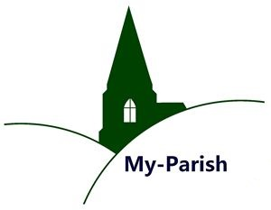

Our annual symposium will take place on Saturday 20 May 2017 between 10.30 and 6. This year we focus on the many opportunities and challenges presented by the digital turn: new research approaches, online editions, 3D modelling of churches and dedicated websites (to name just a few), but also issues of data management / preservation and absorbing / evaluating ever more plentiful information. The choice of theme marks the final preparations for the ‘English and Welsh Churchwardens’ Accounts Database’ to be featured on My-Parish and we are delighted that Valerie Hitchman, initiator and co-ordinator, will be speaking about the project. Other papers deal with database / online projects relating to England and Poland.
For the programme and (mandatory) online registration (by 1 May 2017) please visit:
http://www.warwick.ac.uk/my-parish/parishsymposia/2017digitalparish/.
Contact: Beat Kümin (b.kumin@warwick.ac.uk)

