REFUGEES IN POST-CONFLICT RECONSTRUCTION: A STUDY OF KAKUMA AND DADAAB REFUGEES IN KENYA.

By

Elias H.O. Ayiemba, PhD
Professor and Chair
Department of Geography and Environmental Studies
University of Nairobi
P.O. Box 30197, 00100, GPO
Nairobi, Kenya
Email: olayiemba@yahoo.com

Paper for the Conference on African Transnational and Return Migration in the Context of North-South Relations at the University of Warwick, Coventry, United Kingdom, 29-30 June 2009

Abstract

The Horn and Great Lakes Region of Africa is a global hot-spot generating annually thousands of refugees. Kenya however, unlike other states in the Horn of Africa has had relative peace since independence in 1963. Kenya is therefore a safe haven for the influx of refugees from the neighbouring politically unstable and war-torn countries. The main objective of this paper is, therefore, to identify positive roles that transnational communities in the two major refugee camps in Kenya namely Kakuma and Dadaab camp complex, play in post-conflict reconstruction of their home countries. The study has been limited to library research due to limited time. It is estimated that, as of May 2009, Kenya had approximately 357,635 documented refugees in different parts of the country. Nairobi had 34,436, Kakuma 51,336 and Dadaab 255,748. The voluntary repatriation for the Sudanese refugees started in December 2005. Since then a total of 37,747 have returned to different states in South Sudan. Of these, 16,085 (43%) have returned with the assistance of UNHCR while 21,662 (57%) have spontaneously returned.
It is found that transnational communities play a critical role in post-war construction and reconciliation by promoting establishment of good governance in their home countries. They enhance the flow of remittances to families and relatives left back home to support investments, improve the quality of human and social capital in terms of “social networks” formed, that positively contribute towards sustainable development of their countries of origin. The study recommends that the Government of Kenya should enact policies that give more protection to the rights of refugees and enhance development of their skills for sustainable development of their countries of origin.

INTRODUCTION

Refugeism, as a development issue, is intricately part of human civilization dating back to the early phases of human habitation of the earth. Its causes, effects and solutions are therefore complex. Globally, its primary victims are individuals whose movements exert great pressure on the environment, society and governments, depending on the population size, characteristics of refugees, duration and frequency of their migration.

The Horn and Great Lakes Region of Africa is a global hot-spot generating annually thousands of refugees (Ekuru, 2004; UNHCR, 2005, UNHCR, 2009). Kenya, however, unlike states neighbouring it in the Horn of Africa, has had relative peace since independence in 1963, except for the brief political debacle over the December 2007 general elections. Conclusively, Kenya is a safe haven for the influx of refugees from the politically unstable and war-torn neighbouring countries of Somalia, Ethiopia, Eritrea, Sudan, Congo DR, Rwanda and Burundi (GTZ/UNHCR/GOK, 1999, UNHCR, 2009). This view does not overlook the impact of environmental hazards as responsible for environmental refugees that are found in nearly all countries in the Horn of Africa (Myers, 1993).

The Kenya Government ascribes to the narrow concept of “political refugee” because of political and economic expediency. Gallager (1989) reports that “the African refugee problems were originally recognized as being temporary and, once resolved, would permit refugees to repatriate voluntarily to their countries of origin.” This view is based on the premise that some political refugees are in transit to a third country for asylum and would relocate once this country is determined. Furthermore, the traditional concept of “a political refugee” assumes that the full responsibility for livelihood of refugees is the sole responsibility of the United Nations High Commission for Refugees. The responsibility of the host country is thus relegated to the provision of security and the maintenance of law and order within the refugee camps (Ayiemba and Oucho, 1995).

Available literature on refugees portrays largely a rather negative perception on their role in socio-economic development of countries of origin and asylum. Traditionally, refugees are associated with all kinds of societal and environmental evils, such a: arms and drugs trafficking, violations of human rights, especially against women and children, disease epidemics, and environmental degradation among many others (Blondel, 2000; Ayiemba and Oucho, 1995; Rogge,1990; UNHCR, 2009). For this reason, the positive role of refugees in post-war reconciliation and reconstruction of the countries of origin has been put in the back burner of academic discourse and policy redress. This situation arises from the reality that refugees are responsible for the evils noted and probably because international aid is a lucrative business whose perpetuation depends on portraying negative aspects of refugeism in the international arena.

The main objective of this paper is therefore to identify positive and negative roles that transnational communities in the two major refugee camps in Kenya, namely Kakuma and Dadaab camp complexes, play in post-conflict reconstruction of their home countries (figure 1). Emphasis is on how they have addressed insecurity matters in the context of inter and intra-state peace building efforts; the nature and magnitude of remittances to families and relatives left back home; the quality of human capital of returnees, whether spontaneous or forcefully repatriated; and the nature of social capital in terms of “social networks” formed, that positively and negatively contribute towards sustainable development of their countries of origin.

The study has been limited to library research and internet search since the time allocated for writing the paper could not allow for field-work to collect primary data. This attempts to shed light on the nature of the two camps whose demographic, cultural and socio-economic characteristics are assumed to be different. Furthermore, it will highlight the positive roles of refugees that scholars and policy-makers should address for programme implementation.

CONCEPTUAL FRAMEWORK

The conceptual framework proposed has four distinct levels of analysis and operation (Figure 2). The first operational level which is assumed to have distant effect on refugee movement is referred to as governance status of the refugee country of birth or origin. Conceptually, good governance will embrace policies and programmes that protect the environment, promote social and economic equity, and cultural development that reinforces social, economic and national harmony. It will also protect human rights and will promote gender equity, employment, security and national cohesion, among many other factors which are considered as pillars of good governance. Good governance, therefore, has checks and balances that mediate on the second category of factors that are assumed to have direct effect on the decision-making process that trigger refugee movements.

The second category of factors is grouped into three blocks of factors. Each block is assumed to have similar operational factors. In this group, the first block of factors comprises environmental forces. Elements of ecostress such as prolonged drought and famine, disease epidemics and earthquakes are known to trigger mass refugee movements often referred to as environmental refugees. The other block of factors in this category consists of socio-economic and cultural forces, unemployment, family disagreements (disputes), violation of cultural norms and practices, ideological differences, and religious intolerance among others. These factors are also known to cause individuals or groups of people to flee from their home countries. The last block of factors in this category embraces actual threat to one’s life due to political persecution, ethnic cleansing, civil war and religious persecution. All these second category of factors have a direct impact on decision-making process that determines whether one becomes a refugee or not.
Figure 1: the location of Kakuma and Dadaab Refugee Camps
XXXXXXXXXXXXXXXXXXXXXXXXXXXXXXXXXXXXXXXXXXXXXX
Refugees from the camp carrying fire wood

The third category of factors relate directly to the actual process of decision to become a refugee or not. The decision is always taken at individual or household level. In some nomadic communities this decision is made at community level by the Council of Elders. Usually, the decision is made to either emigrate and become a refugee or stay and not become a refugee.

The fourth stage is that of actual refugee movement. This stage has only two categories of refugee’s: namely, voluntary refugee or involuntary refugee. A voluntary refugee is a person who on his own violation has weighed the pressures on him to move and has decided to do so as in the case of some environmental and economic refugees. On the other hand, an involuntary refugee is one coerced by conditions around him or her to move in order to save his or her own life. The other block in this category consists of those who despite all forces reinforcing the need to move have resisted movement. These could be men in the household who have decided to remain and fight against their oppressors or those in privileged position in the society who are shielded in one way or another.

Finally, analysis is on refugees who later may decide to return to their countries of birth to participate in post-conflict reconstruction and reconciliation activities. Our literature search confirmed that very little information exists on this matter for transnational communities in Kenya.

A SYNOPSIS OF KENYA’SREFUGEE POPULATION

It is estimated that as of May 2009, Kenya had approximately 357,635 documented refugees in different parts of the country. The majority arrived during the first half of the 1990s due to civil conflicts in Somalia and Sudan. In response to the mass immigration of refugees, the Government of Kenya established 15 camps to accommodate the arrivals (Figure 1). In 1998, these camps were consolidated into four camps which currently host 322,840 or 90.3% of all refugees (UNHCR, 2009). The remaining 34,795 (9.7%) are settled in various urban centres throughout the country. The dynamic nature of refugee population makes difficult precise estimation of urban refugee population, though UNHCR settles for 15,000, while other independent estimates give a number of 60,000.

The Somali refugees are the dominant ethnic group and were estimated to be 278,014 (77.7%) by May 2009. They reside largely in Dadaab camp complex in the North-Eastern Province of Kenya. They predominantly belong to the main Somali clans of the Darood, Rahaweyn, Hawiye and Issak. There is also a large population of minority groups including the Somali Bantu, Ashraf, Bajuni, Barawa and Benadir. Most of these refugees fled into Kenya following the collapse of the Siad Barre government and subsequent outbreak of civil war in Somalia in 1991, and were relocated to Kakuma following the closure of the coastal camps in 1997. The number of Somali refugees in Kenya has been changing from time to time: the Kenya population census of 1999, reported 176,816 Somali refugees in 1997, dropping to 164,657 in 1998 and 141,088 in 1999. Deteriorating conditions in refugee camps in Kenya have forced some Somalis to relocate to a third country of asylum just as in the case of Somalis who transferred from Denmark to England because they perceive England as less xenophobic than Denmark. These migrants are well educated seeking employment and better livelihood conditions (Gundel, 2003).
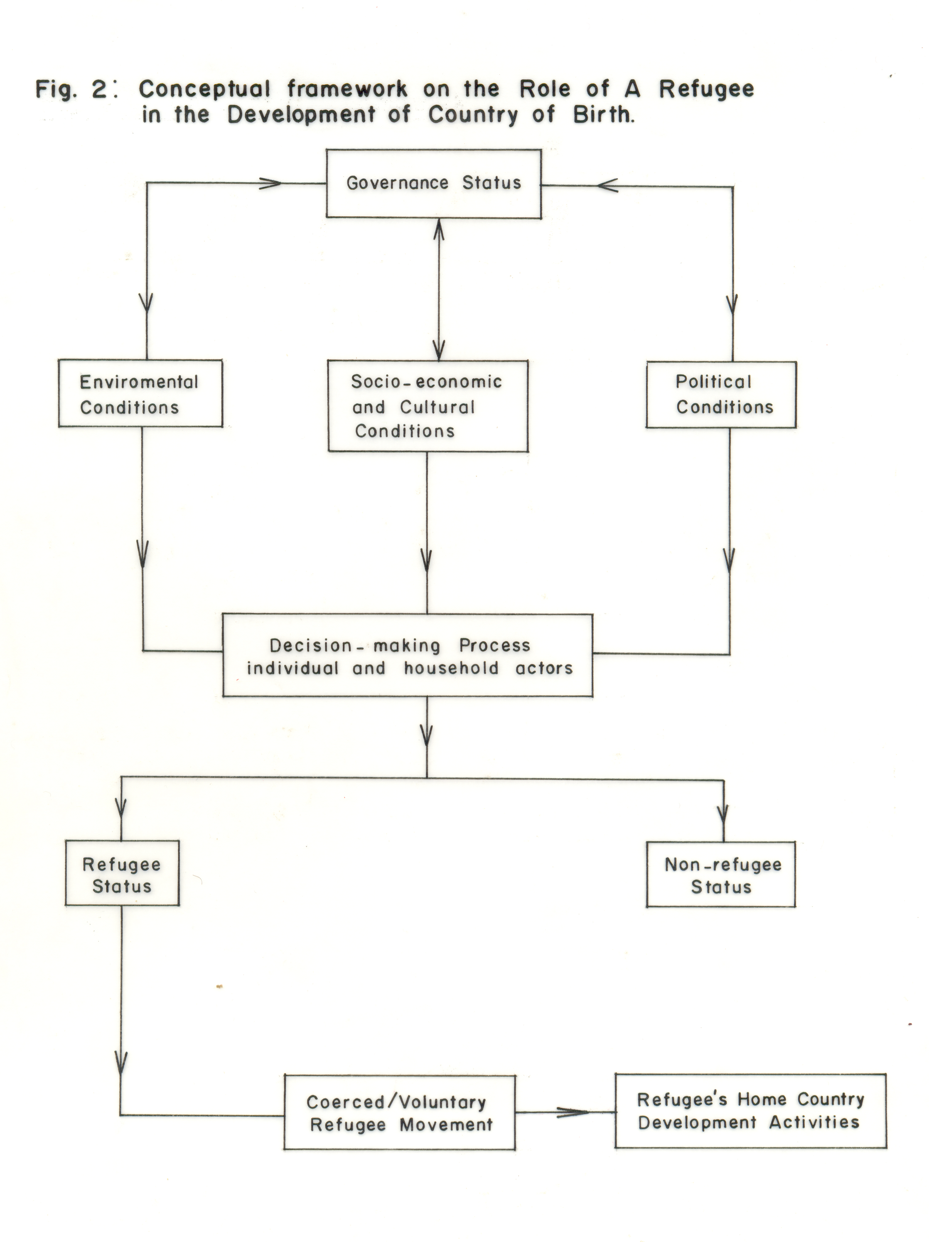
Sudanese refugees constitute the next largest group of camp-based refugees and reside primarily in Kakuma camp in the Turkana Division of North-western Kenya. Figure 3 shows the proportions of refugees in Kakuma, Dadaab and Nairobi as at March 2009 (UNHCR, April 2009). Ethiopian refugees account for the third largest group. They are of Amhara, Tigryan and Oromo origins as well as smaller ethnic groups from the southern regions of Ethiopia. Other nationalities who comprise a minority group are Rwandese, Burundians, Congolese, Angolans, Eritreans, and Sierra Leoneans. Further reference to Table 1 portrays the distribution of the same refugees by country of origin. It is observed that Somalia, Sudan and Ethiopia are the leading countries sending refugees into Kenya.

Fig. 3 Proportion of refugee arrivals in Nairobi, Kakuma
and Dadaab
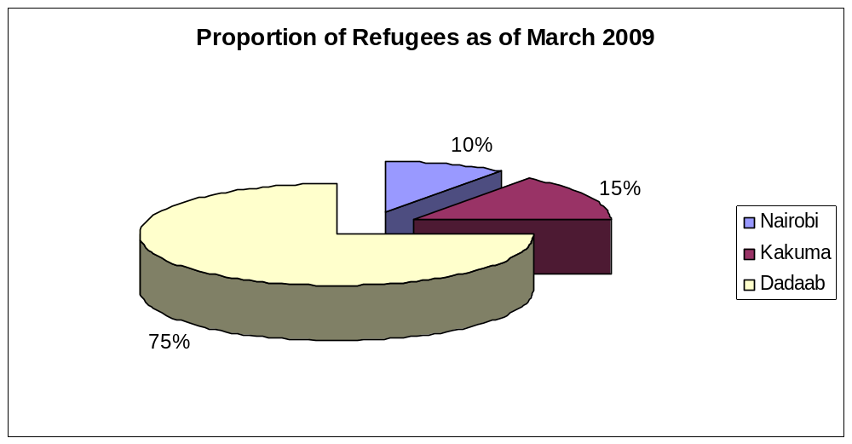

Source: UNHCR database,2009
The significance of Rwanda, Uganda and Burundi has declined with time because of the relative peace in these countries today.

Table 1 Refugee Arrival Trends as of March 2009.
Country of origin | Dadaab | % of total | Kakuma | % of total | Nairobi | % of total | Total | % of total
Somalia | 244,580 | 95.6 | 19,431 | 38.5 | 14,580 | 42.3 | 278,591 | 81.8
Congo DR | 58 | 0.0 | 93 | 0.2 | 2,015 | 5.8 | 2,166 | 0.6
Sudan | 640 | 0.3 | 24,986 | 49.5 | 2,139 | 6.2 | 27,765 | 8.2
Ethiopia | 10,273 | 4.0 | 4,865 | 9.6 | 9,489 | 27,6 | 24,627 | 7.2
Rwanda | 18 | 0.0 | 356 | 0.7 | 2,148 | 6.2 | 2,522 | 0.7
Uganda | 75 | 0.3 | 404 | 0.8 | 2,313 | 6.7 | 2,792 | 0.8
Eritrea | 82 | 0.3 | 74 | 0.1 | 675 | 2.0 | 831 | 0.2
Burundi | 14 | 0.0 | 284 | 0.6 | 1,075 | 3.1 | 1,373 | 0.4
Others | 8 | 0.0 | 8 | 0.0 | 2 | 0.0 | 13 | 0.1
Total | 255,748 | 100. | 50,496 | 100.0 | 34,436 | 100.0 | 340,680 | 100.0
Source: UNHCR Fact Sheet, March 2009

In addition, there were 8,400 official refugees who lived in various urban centres of the country (UNHCR, 2001). Many are undocumented refugees scattered in different parts of the country, though the greatest concentration is in the City of Nairobi, especially in Eastleigh Ward where the large population of Somali refugees has been an “eye-sore” to the local residents (Wandibba and Ayiemba, 2006) as they live in filthy conditions.

Clearly, statistics on refugee population in Kenya are rather dynamic, changing from time to time and from camp to camp depending on the relative peace in the country of origin. This arises from the UNHCR policy of repatriation and political climate of the host country as well as the homeland. The fluid nature of Kenya’s borders with her neighbouring war-torn countries and the spill-over of similar ethnic communities along such areas render control of refugee’s movements rather difficult, because of poor policing of borders.

LOCATION AND POPULATION OF KAKUMA AND DADAAB CAMPS

Figure 1 shows the location of the two major refugee camps in Kenya: Kakuma Refugee Camp is in Turkana Division in Northwest Kenya, about 95 km from the Kenya-Sudan border and 1000km from Nairobi. It was established in 1992 to encamp 10,000 Sudanese refugees fleeing fighting between the Government of Sudan and the Sudanese People’s Liberation Army (SPLA). In 1998, Kakuma phase II was opened primarily for Somali refugees who were relocated from camps in Mombasa. In 1999, Kakuma phase III was opened in order to cater for more Sudanese refugees. Phase III however, has rapidly expanded to cater for other nationalities. The population of refugees in Kakuma has been dynamic reflecting the political temperature in South Sudan and other neighbouring countries. In 2002 the refugees were about 84,000 and by May 2009 the number had dropped to 42,304 (UNHCR, 2009). Table 1 summarises the actual population of registered refugees in the camp.

The most striking feature of the refugees in Kakuma camp is the relatively large proportion of its youthful population aged between 18 and 55 years (Table 2). This young adult population of all nationalities in Kakuma camp constituted approximately 48 % of the total population in the camp. The predominance of children and women in these camps has not changed much. Jamal (2000) reported that, over 50 % of the population in Kakuma camp, was below 18 years of age. It is assumed that the young adult population aged between 18 and 55 years as indicated in Table 2, should play an active role in post-war reconstruction and reconciliation of their home countries whether they return or not. While most of the refugees in Kakuma camp in March 2009 were from Sudan (49.5%), the remainder were from Somalia (38.5%), Ethiopia (9.6%), Uganda (0.8%), Rwanda (0.7 %), Burundi (0.6 %), and Eritrea (0.1%). Kakuma town has also increased in size from 5000 in 1990 to 40,000 in 2000 and much more today. This growth trend has been influenced too by local migration into the town. The majority of Kakuma camp refugees from Sudan have been “victims of the imposition of Islamic Laws that caused rebellion among southern Sudanese Christians and animists leading to insurgency led by SPLA” (Gil, 1992).

The voluntary repatriation for the Sudanese refugees started in December 2005. Since then a total of 37,747 have returned to different states in South Sudan. Of these, 16,085 (43%) have returned with the assistance of UNHCR while 21,662 (57%) have spontaneously returned (UNHCR, 2009). From the beginning of 2009 to date UNHCR has assisted only 516 Sudanese refugees to return home. Table 3 gives a summary of mode of transport used by returnees. It is observed that the number of returnees in 2007 doubled that of

Table 2 Refugee Population by Age and Sex in Kakuma Camp May 2005.
Age-group Male % of Total Female % of Total Total % of Total
0-5 6,366 7.4 5,690 6.6 12,056 14.1
6-17 18,365 21.5 12,780 14.9 31,150 36.4
18-25 14,547 17.0 6,155 7.2 20,702 24.2
26-25 10,194 11.9 9,948 11.6 20,142 23.5
56 + 682 0.8 829 1.0 1,506 1.8
Total 50, 154 58.6 35,402 41.3 85,556 100.0
_____________________________________________________________
Source: UNHCR Fact Sheet, 2009.

Table 3: Sudanese Refugees Returning Home from Kakuma Camp
Ye Year | Air | Road | Spontaneous | Self Assisted | Total
2005 | --- | 131 | 2 | ------ | 133
2006 | 1567 | 240 | 5666 | 9 | 7482
2007 | 3010 | 1762 | 14451 | 14 | 19,237
2008 | 2599 | 5898 | 1370 | 9 | 9876
2009 | ------ | 516 | 173 | ------- | 689
Totals | 7176 | 8547 | 21,662 | 32 | 37,417
Source: UNHCR Fact Sheet, 12 May 2009

2006 and 2008 and, that since 2007, the number of refugees returning home has declined. This probably reflects the effect of feedback information on the fluid political conditions of post-war reconstruction in South Sudan. Also, logistical problems experienced by UNHCR in repatriation of refugees as well as transport problems experienced by self assisted refugees desiring to return home could contribute to this declining trend. UNHCR (2005) reports that the majority of Sudanese refugees are pastoralist Dinkas from Bahr-el- Ghazal and Upper Nile; and Nuers from the upper Nile regions of Southern Sudan. Ethnically, the Dinka, Nuer and Bari speakers originate from the Equatorial Province of Southern Sudan.

The second locality is Dadaab camp is in Garissa District of North-Eastern Kenya and 100 km Northeast of Garissa town, 500km from Nairobi and 80 km from the Kenya/Somalia border. It was established in 1991 and has three camps, namely, Ifo, Dagahaley and Hagadera. All the three camps are within 18-km radius of Dadaab town and cover a total area of 50 km^{2.} In 2002, it had a population of more than 130,000 refugees (Government of Kenya 2002). Almost all of them (97%) were from Somalia (UNHCR, 2001), and the remaining 3 % were from Ethiopia, Eritrea, Sudan, Uganda and Congo DRC (Musau, 2001). More recently, the rise of Islamic fundamentalists in Somalia has complicated refugee movement into the camp. As of 30 April 2009 Dadaab refugees camp complex had a very large population of 271,105 refugees, out of whom 257,977 (95.2%) are mainly from Somalia and the remaining proportion from other nationalities as depicted in Table 4.

Table 4 The refugee Population in Dadaab Camp complex
Country of origin Hagadera, Ifo Dagahaley Total
Somalia 90,805 85,606 81,566 257,977
Other nationalities 1,925 7,471 3,732 13,128
______________________________________________________________
Total 92,730 93,077 85,298 271,105
% increase since Jan-2008 32% 51% 115% 58%

Figure 4 Dadaab population trends (2002-2007)
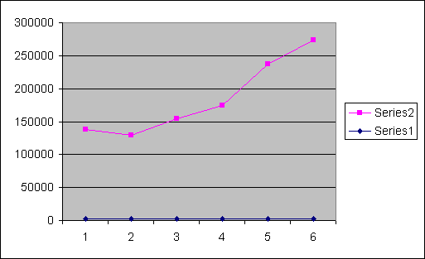

Key: 1 represents year 2002 and 6 year 2007

Ethiopian and Eritrean refugees in Kenya have been more reluctant to embrace the voluntary repatriation project organized by the UNHCR because of their concerns about general conditions in their homeland. This confirms the dynamic forces of some Third World conflicts where there has been fierce competition for political power among rival ethnic groups as observed in Ethiopia, Somalia and Sudan (Gil, 1992). This has constantly fuelled refugee movements into the relatively peaceful Kenya. The report by De Monteclos and Mwangi (2000) suggest that Dadaab camps have a relatively greater mix with the local population, especially in Dagahaley and Hagadera than in Kakuma camp.

REFUGEES’ CONTRIBUTION TO HOMELAND POST-CONFLICT RECONSTRUCTION

The effectiveness of returnees in their homeland post-conflict reconstruction depends on several conditions. Manani (2008) summarises these conditions as stipulated in the UNHCR principles for voluntary repatriation, namely: the decision to return is voluntary and well informed; the country of return is safe in all aspects; legal, physical and material; and the return should be undertaken in dignity, ensuring unity ensured.

These conditions may be difficult to satisfy completely, especially in countries undergoing transition from war to democratic system of governance. For this reason, UNHCR can facilitate return even where conditions do not allow for a return in safety and dignity, should refugees decide to return in such situations. In addition, self-repatriated refugees are not entitled to food rations by UNHCR when back at home. Thus, when a refugee weighs conditions in the refugee camp against difficult conditions at home such as insecurity, human rights abuse, poor medical conditions, poor education, dilapidated infrastructure and threat of landlessness, among others, they may decide not to return. Most refugees therefore find themselves in a state of uncertainty whether to return or not. One Sudanese refugee at Kakuma camp stated that “Sudan is my country. It may not be developed like Kenya, but I want to go and help develop my country” (Manani, 2008). The desire to return home is, therefore, compelling among some refugees no matter the prevailing conditions at home.

Refugee camps are concentrations of people, trading centres, labour markets and social networks. These are features with great potential for stimulating socio-economic development. The impact of these factors however depends on a myriad of factors. As previously noted, lack of empirical data has limited the analysis to generalization based on secondary data.

Observations from the numerous literatures on refugees returning to their countries of origin to participate in post-war reconstruction show limited impact of returnees, because some of these countries are still in transition towards achieving lasting peace that could guarantee security and reconciliation among warring groups. This is particularly the case with Somalia and Congo DRC whose refugees reside in Dadaab and Kakuma refugee camps respectively. Nevertheless, some degree of political normalcy has been achieved in Sudan and Eritrea, while greater peace and stability is now observed in Ethiopia, Rwanda and Burundi which now receive relatively huge numbers of returnees. Somalia’s case has been complicated by resurgence of conflicts which has caused new influx of refugees into Kenya.

The Path towards “Good Governance”

Peace is a prerequisite for socio-economic, cultural and political development in a country torn apart by civil war, ethnic cleansing, religious intolerance and other vices. The process of healing and reconciliation must start with individuals. A good example of such initiative is shown by David Niyonzima, a Burundian refugee in Kenya in 1998, who initiated a very important local organization in Burundi with acronym THARS (Trauma Healing and Reconciliation Services). This is a Non-Governmental Organization whose members are psychosocial practitioners and peace makers who contribute to the healing and peace making in Burundi and the Great Lakes Region of Africa. This local organization started operations in 2000 and is a member a member of the AMAHORO (PEACE) COALITION, another group of agencies working for peace in Burundi. It is noted that planting seeds of peace, Burundi now enjoys national security and stability both of which are the cornerstone of socio-economic development http://www.thars.org). Such initiatives are being duplicated in the countries torn by wars in the Horn of Africa and the Great Lakes region in order to establish good governance.

The diaspora can be more effective in promoting peace in the homeland if they downplay political activities (Mohamoud, 2006). Peace can be promoted through development, social networks, and civic institutions. For example, Somalia diaspora in Nairobi peace negotiations in 2003/2004 availed their expertise to bring warring parties together. The diaspora have also used their expertise to assist their homeland government draft policies for social, political and economic reconstruction. They have assisted their governments to restructure the justice system and to disarm the militias as cited in the case of Eritrean diaspora who helped who helped to draft the first constitution of the country after its separation with Ethiopia in 1993. In turn the new government rewarded the Eritrean diaspora by granting them voting rights in future elections of the country (Muhamoud, 2006).

In contrast some diasporas seek solutions to political problems in the homeland by supporting rival political groups instead of promoting reconciliation. The Government of Kenya and its citizens, particularly residents of North-Eastern Kenya, are therefore concerned about constant political instability in Southern Somalia which causes cyclic influx of refugees into Dadaab and Kakuma camps. Such refugees are often accused of fanning flames of political instability through intricate ethnic, economic and political networks that support insurgency in Somalia. These are undeniable facts supported by ample documented evidence (UNHCR, 2009).

On the other side of the coin, some Somali refugees in these camps, teaming up with refugees outside the camps in Kenya, have been a source of inspiration and economic support to their “Government in Exile” in Kenya. The primary objective of this government has been to rebuild “good governance” in Somalia. This path towards good governance (transitional government), though treacherous in Somalia due to activities of al-Shabaab militia and their Islamist allies, has received overwhelming international support. Dembowski 2004, reports that:

Somalia has crossed an important hurdle on the road to peace and stability. In early September 2004, the new national assembly, agreed upon in January by the main clan leaders, and President Adulkassim Salat Hassan’s transitional government was inaugurated in Nairobi Kenya….The UN Secretary General, European Union and the US Government welcomed the opening of parliament, which owes much to the persistent brokering of the IGAD.

Since this government was inaugurated, it has been beset by many obstacles from internal and external forces. Nevertheless, it demonstrates that not all refugees in Kenya are “rotten apples”. There are some who engage in post-conflict reconstruction of their home countries an effort to pursue the path of good governance. It is similar pursuits that enabled Rwanda, Uganda and, more recently, South Sudan to walk on the path to “good governance”. In addition, Eritrean and Ethiopian refugees in Kenya and Sudan have also played the positive role to assist their revolutionary groups in Ethiopia and Eritrea by giving substantial financial support.

The Refugee Consortium of Kenya (KCR) in 2006 launched A Paralegal and Alternative Dispute Resolution training project for Sudanese refugees in Kakuma camp. The project organizers recognized the fact that, South Sudan had a difficult task of building a formal justice system which could respect concepts of human rights and modern law (Mutai, 2008). This initiative also recognises the role that a good justice system in democratic governance. Therefore, by training a new generation of legal professionals among refugees, a critical mass of professionals equipped with basic legal and dispute resolution skills was being prepared to fit better into the new social environment to which they were returning. Manani (2008) argues that, skills acquired by Sudanese refugees with such training would facilitate their participation in community education of their homeland and help them get jobs. One such trainee was employed as a local administrator in South Sudan.

In the case of Somalia, the role of diaspora in civic-oriented institutions in their homeland is well documented by Kent et al. (2004). The authors observe that while Somali state institutions are in a state of collapse, Somali society has not collapsed, because its widely dispersed population of refugees and migrants continue to play a crucial role in sustaining economic survival in major segments of the country especially in urban areas. The private sector is, therefore, the economic mainstay of the country. The UNDP Qualified Expatriate Somali Technical Support (QUESTS) project has helped to promote human capital development in areas of stability (UNDP, 2008).

Enhancing Remittances
An interview given by Rita Sussmuth, the German member of the Global Commission on International Migration revealed that in 2003 transnational communities globally remitted 93 billion dollars to developing countries. This was one-and a half times as much the amount of official development aid (Dembowski, 2004). In reality, such figures are just a tip of the ice-berg because the amount of money remitted informally across borders is not known. These remittances supplement efforts of countries of origin in capacity building, business investment, technology transfer, human capital development and infrastructure, and livelihood strategies of those left behind among others. As Rita Sussmuth correctly observed, such remittances may also be put into investments that support activities fanning flames of conflict and consequently undermining efforts of post-war reconstruction and reconciliation. Werner Mundt (2004) supports this view, arguing that:

[E]migrant’s remittances can have negative macroeconomic effects. For example, they can push up the value of the recipient country’s currency or prevent it from sliding down. In the long term, remittances can impair competitive strength, aggravate balance of payments deficits and thus have a negative impact on economic growth.

These conditions can slow down post-conflict economic development. In the case of Kakuma and Dadaab camps, it has been difficult to obtain data to support these views from refugee’s countries of origin. The limitation of time has also prevented actual field survey to gauge how much refugees repatriate to their home countries.

Horst and Van Hear’s (2002) study of Somali refugees reveals that, through an informal banking system (xawilaad), many refugees receive cash-transfers (per wire) from Somali Diaspora in South Africa, Canada, the USA, Kenya and other countries. This indicates that networks among family members are strong and has a bearing on post-war reconstruction and reconciliation efforts. They reiterate that there are two forms of financial remittances to Somalia, namely individual and collective. Individual remittances go to families and relatives to meet basic livelihood needs. Such remittances have both beneficial and negative impacts on beneficiaries and homeland country, especially in the case of societies in conflict (Van Hear, 2003). Remittances, for example, can enhance inequalities because of the unevenness in their distribution, and can fuel the flames of conflict in the homeland by funding warring groups (Van Hear, 2003). A case in point is Eritrea where diaspora have actively supported the struggle for independence and continue to play an important political role (Koser, 2oo1).

Various estimates in 2003 indicate the Somali diaspora remitted over one billion US dollars to Somaliland and Somalia (Ahmed, 2000; Horst and Van Hear, 2002; and Peres de Montclos, 2003). Such remittances have exceeded International aid (Gundel, 2002; Lindley, 2005). Lindley further states that remittances are vital in promoting homeland trade and business. The amount remitted between Camps in Kenya and Somalis homeland has been difficult to know (Horst, 2002). This is because such remittances take many forms such as cash in kind, material goods or are channeled through merchants and trusted hand-carriers. Furthermore, the number of refugees in the Diaspora is not known and xawilaad (money transfer companies), who are responsible for a significant part of transfers sometimes deliberately under-report the amount they transfer in order to avoid heavy taxation by homeland government. Recent estimates indicate that Diaspora remittances amounted to US dollars 1.6 billion to Somalia and US Dollars 700 to Somaliland (Lindley, 2007). According to UNDP/World Bank 2003, remittances from the Diaspora represent 23% of the Somali household income. This proportion could rise to 25% as observed in Hargeisa households (Lindley, 2007).

It is however acknowledged that though majority of encamped refugees are poor, like their counterparts of low social status in Europe and America, some make little savings to send to their relatives back at home. In addition, though it is impossible for individual remittances to be used to finance conflict efforts, collective remittances (money collected from the diaspora for particular purposes) are used to finance war activities (Horst and Van Hear, 2002).

Building Social Capital for Development
The concentration of different ethnic groups in refugee camps creates high potential for rapid diffusion of cultures and renders such camps to become cultural melting-pots. These camps for all practical purposes have features of urban development. One aspect of this development is the emergence of different types of social networks that constitute components of social capital. Research has revealed that extended families across international borders create functional family networks that reinforce easy absorption of refugees from both sides of the political divide (Ayiemba and Oucho, 1995; Kibreab, 1993 and Unruh 1993). This situation encourages the rise in the number of undocumented refugees in the countries of origin and asylum. Sometimes, social networks have positive and negative consequences for post-war reconstruction and reconciliation at all levels of individual, household and community. Such networks therefore affect conditions for national sustainable development, particularly in trade and commerce, governance and livelihood strategies.

More importantly, intermarriages and other various kinds of social integration between different refugees in camps create new cultural norms and practices which returnees may use to influence positively post-war reconciliation efforts, especially among the youth and young adults. Others argue, that returnees bring social values which are detested by their communities particularly in sexual morality and dressing norms (Dembowski, 2004). Youthful refugees returning home to countries with strong Islamic (Sheria) Laws, wearing earrings and plaited hair, and ladies in mini-skirts are perceived to corrupt the moral integrity of their countries of birth. Brain gain for the refugee’s country of birth is a reality in most cases. Labour migration networks based on friendship bonds constructed in refugee camps could be utilized either positively in the supply of needed manpower for reconstruction or used to undermine such efforts. A good example is Southern Sudan which has benefited from voluntary repatriation of Sudanese migrants from Kakuma refugee camp. Some of these returnees acquired different skills while encamped through the assistance of various Aid Agencies. These returnees have therefore bolstered trade, education and other sectors of the economy during post-conflict reconstruction. Sussmuth, however, cautions that “improvements in the country of origin’s local job market can be postponed through the emigration of skilled workers during political instability, especially when those leave permanently and thus reduce the country’s chances of quick development and modernization during post–war reconstruction” (Dembowski, 2004).

In addition, business (trade) networks forged in refugee camps or outside the camps in the host country have been instrumental in post-war reconstruction of countries of origin as seen in Rwanda, Burundi, Uganda and South Sudan. Refugees are known to be hard working and adventurous if allowed freedom to invest in their countries without too much legal and financial restrictions. Such business networks provide the needed foreign exchange and material goods for reconstruction. UNHCR 2005 reports that refugees in both camps practice a wide range of micro-business activities and private entrepreneurship. These include collection of firewood, food preparation, tailoring, welding, carpentry, small-scale sale of general goods (petty trade), and transport of goods within the camp, among others. Such activities show that a strong entrepreneurial spirit exists in these camps. Crisp 2000 reports that in Dadaab camp complex, there were about 30,000 goats/sheep, 9,000 cows, 3,500 donkeys and 500 camels. Some of these livestock are sold to supplement income which may be used to support other development projects in Somalia.

In this technological age information flow linkages among refugees and their homeland deserve special attention. Information flow through traditional methods such as postage of letters, telegraphic facilities, telephones and third party messages are being replaced with modern methods such as cell phone, email and other internet facilities which accelerate international money transfer electronically. This has stimulated the growth of International money transfer banks such as Western Union, Money gram and Post pay that help raise tax revenues for the country of origin and asylum. Cheap and quick flow of information to family members, friends and business associates also help in prompt and informed decision on all matters that may affect positively development at all levels of decision-making. In the same vein, such information flow could also undermine post-war reconstruction and reconciliation by promoting illegal trade, insecurity and dissemination of hate messages and other criminal activities in the general population.

These views are succinctly stated by Rita Sussmuth in her interview. She states that “diaspora communities have the opportunity of staying closely in touch with their home countries. Transnational communities are evolving and forming cross-border networks.” The experiences that transnational communities have acquired in democratic political organisations and socio-cultural practices can contribute to development of their home countries. For this reason, Sussmuth argues that “transnational communities are both a cause and result of the changing traditional concept of belonging to one state. A new concept of belonging is emerging in which the country of origin becomes the country of cultural identity and the country of residence becomes the country of rights and obligations, and the transnational community becomes the basis for political activity” (Dembowski, 2004).

Since most refugees fleeing from their homeland are rural farmers, when they return home they are forced to become landless as is the case in Northern Uganda and Burundi. This situation limits their participation in post-conflict reconstruction and reconciliation. Muthama (2008) reports that returnees in Northern Uganda found that their family land became the property of new owners during their exile. Disputes over land ownership are threatening the resettlement of many returnees in Acholi region of Uganda. The situation is worse when the Government actually evicts communities from their communal land. In such conditions land productivity during post-conflict reconstruction is affected. Landless returnees have also been reported in Burundi from those repatriated from camps in Tanzania. Some of the refugees are denied land for settlement by their own family members.

In Somalia renewed fighting in Hodan and Halwadag districts south of Mogadishu has forced returnees to flee again thus limiting their active participation in development of their homeland. Similar conditions are experienced along Congo-Sudan border where sometimes even children are abducted from school by insurgents.

Conclusion
The study reveals that adequate knowledge is scarce on the contribution that transnational communities in Kenya make towards post-war reconstruction and reconciliation in their countries of origin. Out of the 357,635 documented refugees in the country by May 2009, only 37,747 (10.6 %) have returned to their home countries. Somali refugees have been worst affected by recurrent civil wars in Somalia. As a result, their contribution to rebuilding their country has been greatly hampered.

The most striking feature of the refugees in Kakuma and Dadaab camps is the relatively large proportion of youthful population aged between 18 and 55 years. This young adult population of predominantly children and women is below 18 years of age. It is however assumed that the young adult population aged between 18 and 55 years as indicated in Table 2, should play an active role in post-war reconstruction and reconciliation of their home countries whether they return or not.

Some Somali refugees in these camps teaming up with refugees outside the camps in Kenya have been a source of inspiration and economic support to their “Government in Exile” in Kenya. The primary objective of this government has been to rebuild “good governance” in Somalia. This path towards good governance (transitional government), though treacherous in Somalia due to activities of al-Shabaab militia and their Islamist allies, has received overwhelming international support.

The remittances by refugees supplement efforts of countries of origin in capacity building, business investment, technology transfer, human capital development and infrastructure, and livelihood strategies of those left behind among others. Such remittances may also be put into investments that support activities fanning flames of conflict and consequently undermining efforts of post-war reconstruction and reconciliation (Dembowski, 2004).

The concentration of different ethnic communities in refugee camps creates high potential for rapid diffusion of cultures and renders such camps to become cultural melting-pots. One aspect of this development is the emergence of different types of social networks that constitute components of social capital. Sometimes, social networks have positive and negative consequences for post-war reconstruction and reconciliation at all levels of individual, household and community. Such networks therefore affect conditions for national sustainable development, particularly in trade and commerce, governance and livelihood strategies.

The study recommends that both UNHCR and other agencies catering for the welfare of refugees in camps should team up with the Government of Kenya to collect relevant data on refugees repatriated to their countries of birth. Such data aggregated by age, sex and socio-economic characteristics should indicate contributions returnees make in socio-economic development of their home countries. This may help all stakeholders catering for the welfare of encamped refugees to institute relevant policies and programmes for their human resource development.

It is also recommended that the Government of Kenya should enact policies that protect human rights of refugees and promote development of entrepreneurial skills and investment activities of transnational communities in the country.

References

Ahmed, I.I., 2000: Remittances and their impact on postwar Somali. Disaster, 24(4): 380-389.

Ayiemba, E. and J. Oucho, 1995: The Refugee Crisis in Sub-Saharan Africa: What are the solutions? African Population Paper No. 4, African Population and Environment Institute, Nairobi, Kenya.

Blondel, Nicolas, 2000: Firewood Survey around Dadaab Refugee Camps. EESS Mission Report, UNHCR, Kenya.

Crisp, Jeff, 2002: Protracted Refugees Situations: Some frequently asked Questions. Evaluation and Policy Analysis Unit, UNHCR, Geneva.

Crisp, J. 1999: A State of Insecurity: A Political Economy of Violence in Refugee-populated Areas of Kenya. Geneva, UNHCR. New Issues in Refugee Research Working Paper 16.

Dembowski, Hans. 2004: Parliament for Somali. Development Cooperation No. 10. Vol. 31, October 2004 p. 356.

Ekuru Aukot., 2004: It is better to be a Refugee than a Turkana in Kakuma Revisiting the Relationship between Hosts and Refugees in Kenya. Refugee Vol. 21(3):73-83

Gallagher, D., 1989: The Evaluation of the International Refugees System. International Migration Review 23(3): 579 – 598

Gil, Loescher, 1992: Refugee Movements and International Security. Brassey’s for the International Institute for Strategic Study. Published by
Brassey’s 11SS.

GTZ/UNHCR/GOK., 1999. Evaluation of fuel wood availability and the Impact of Fuel wood harvesting zones. GTZ/UNHDR Report.

Gundel, Joakim. 2002: The Migration-development Nexus: Somalia Case Study. International Migration, 40 (5):254-279.

Gundel, J., 2003: The Migration-development Nexus: Somali case study. In Van Hear N.N. and N.Sorensen (eds). The Migration-development Nexus. Geneva, United nations and International Organization for Migration

Horst, Cindy, 2002: Xawilaad: The Importance of Overseas Connections in the Livelihoods of Somali Refugees in the Dadaab Refugee camps of Kenya. Working Paper, Oxford. Transnational Communities Program. WPTC-02-14.

Horst, C. and Van Hear, Nicholas, 2002: Counting the Cost: Refugees, Remittances and the War on Terrorism. Forced Migration Review, No. 14.

Jamal, Arafat., 2000: Minimum Standards and Essential Needs in a Protracted. Refugee Situation. A Review of the UNHCR Programme in Kakuma, Kenya. Evaluation and Policy Analysis Unit, UNHCR, Geneva.

Kent, Radolph, and Karin von Hippel, with Mark Bradbury, 2004: Social Facilitation, Development and the Diaspora: Support for Sustainable Health Services in Somalia. International Policy Institute, Kings College London. November, 2004.

Kibreab, G., 1993: The Myth of Dependency among Camp Refugee in Somalia 1979 – 1989. Journal of Refugee Studies 6(4): 321 – 349.

Koser, K., 2001: War and Peace in Eritrea, Copenhagen: Conference on “Living on the edge: migration, conflict and State in the backyards of Globalization. Centre for Development Research. Marchal, R. 1996. Final Report on the Post Civil War Somali Business Class. Paris, European Commission, Somalia Unit.

Lindley, A, 2006: Migrants Remittances in the Context of Crisis in Somalia Society: A Case Study of Hargeisa. HPG/ODI. www.odi.org.uk/hpg.

Mohamoud, Abdullah, 2005: Mobilizing African in the Diaspora for the Promotion of Peace in Africa. Policy Report for the Netherlands Ministry of Foreign Affairs Sub Sahara Department (Amsterdam: SAHAN Research

Mohamoud, Abdullah, 2006: Africa Diaspora and Post-conflict Reconstruction in Africa. Danish Institute for International Studies, Strandgade, 56. 401.

Monteclos, M. P. and P.K. Mwangi., 2000: Refugee Camps or Cities? The Socio-economic Dynamics of the Dadaab and Kakuma Camps in Northern Kenya. Journal of Refugee Studies, 17(2): 205 – 2224.

Musau, J., 2001: Protecting Refugees in Dadaab: Processes, Problems and Prospects, Nairobi, UNHCR Office.
Myers, N. 1993: Environmental Refugees in Globally Warmed World
Bioscience, 43(11).

Perouse de Monteclos, M. A, 2003: A refugee Diaspora: When Somalis go West. In Koser, K, (ed.). New African Diaspora. London, Rutledge, 2003.

UNHCR Facts Sheet: 2001, 2002; 2005, 2009, Somali Office, Nairobi.

Unruh, J. D., 1993: Refugee Resettlement on the Horn of Africa. The Refugees Land Use Patterns’. Land Use Policy, 10(1) 49 – 66.

