On the Italian translation of Capital Markets and Debt Management’ edited by Dornbusch and Draghi
Marcus Miller, University of Warwick
Prologue
As one of those invited to the initial conference on ‘Capital Markets and Debt Management’ at Castelgandofo held in June 1989, it was a particular pleasure to be invited to the launch of the Italian translation.
Being scheduled to speak somewhat late in the day, however, and without command of Italian, I was unsure what remarks to prepare. All words of wisdom would already have been said.
My worries were all ended when, at the last minute, a packet arrived by express mail, supposedly from the office of the President of the ECB, addressed to “A speaker giving the point of view of economists’’. Opening the packet, I found a document with the instructions ‘To be presented unchanged on 26 October, 2012’.
It appears to be written in the form of a short Italian miracle play!
So, without further ado, I will present it to you all for your amusement and edification.

Via, andiamo a teatro …

How OMT came to be: a midsummer miracle play
A short play with only three characters and three scenes
To be presented to Conference on Public Debt, La Sapienza, 26/10/2012
NAMES OF THE PLAYERS
RODRIGO: an academic from America, editor
MARIO: a European policy maker, editor,
ARIEL: young economist from La Sapienza, assistant for Mario

Scene One: The meeting on Montecucco
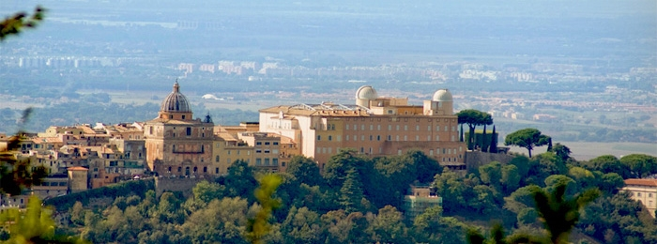
The setting is Villa Montecucco, south of Rome on a hill close to the Pope’s summer residence in Castelgandolfo . The date is 1989 and- at the end of a long debate- the editors, Rodrigo and Mario, say farewell to the assembled participant.
RODRIGO: Our thanks to all who’ve joined us here today
For your thoughts on the vex’d problems of debt.
Your papers, like panels of Michelangelo,
Provide illumination for us all.
What say you Mario? Which like you the best?
MARIO: To me, debt contracts are like lovers vows,
For both are hostages to fickle fortune.
Only time will tell whether they be honoured.
So too with the papers here: who can tell
Which will be forgotten and which do well?
But now, good friends, we will with all good speed
Publish your words for all the world to read.
Exeunt all.

Scene Two: Echoes of Montecucco.
Time has moved on: it is now early summer of 2012, and Rodrigo has left this world for pastures new. As for Mario, he is in charge of European monetary policy, but there is turmoil in the bond markets as speculators bet on the euro breaking up. Mario waits for the latest news from the markets.
Mario’s office in the ECB, in early summer
Ariel enters.
MARIO: What news? How are Italian rates today?
ARIEL: Why sir, higher than yesterday. They look set
to take flight!
MARIO Alas! Leave this with me. You may go.
ARIEL: Go sir? May I now take my summer leave?
For I have a dear friend that lives in Rome,
who pines for me and bids me come.
MARIO: Alas not yet young Ariel. There’s much to do.
We seek for ways to calm this market storm.
I recall a meeting on Montecucco:
Go read this volume of the papers there.
And look at Chapter 4 with special care.
ARIEL: I will sir, and then will I be free?
MARIO: There is another thing
The answer found, it will be little worth,
Unless we persuade our neighbours in the North.
(sotto voce) I mean. those who live by the River Rhine,
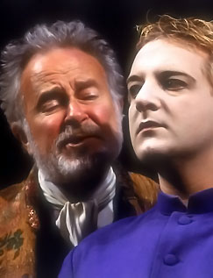
Who speak not Italian and grow sweet wine.
Exit Ariel

MARIO: This is no occasion for idleness and rest.
The time has come to put things to the test.

Scene Three: OMT comes to be
In Mario’s office at the ECB, late summer
Ariel enters.
MARIO: The markets are in turmoil still, so what news?
ARIEL:
The answer found is not for the faint of heart,
To save the Euro, you must be so bold
As to buy all the bonds that others fear to hold!
A floor price for debt puts a ceiling on the spread:
With sufficient courage, speculation will be dead.

MARIO: Ah, I do recall the logic of the plan.
The market may find two places where to rest,
The good where the government pays its debt,
The bad where high rates force a debt default.
By throwing ourselves into the fray
We can prevent the bad and save the day!
Tis a good plan that should soon prove its worth.
But what of the doubters in the North?
ARIEL: For them, sir, it must be the key
To show it’s a proper role for the ECB.
MARIO: I have it!
We will call them Outright Monetary Transactions!
ARIEL: But what of those who are quick to oppose
any money increases, even OMO’s?
MARIO:
We’ll add a fiscal compact to the mix,
As a condition for getting OMT.
More cutting of the sinews of state
I like not. But what of that?
When the market hears of this bold plan,
It will be enough to bring the rates right down..
In the field of finance, expectation is all.
And so it came to pass:
As the market took heart that Mario would act
Sentiment changes and wild spreads contract.
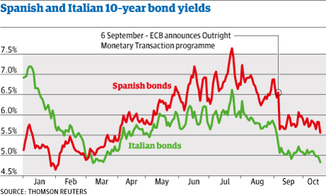
Epilogue: Mario’s office
Ariel waits for Mario to give him leave.
MARIO:
Thanks good Ariel, for a job well done
Just one small thing to do before you go.
A meeting soon is to be held in Rome
To discuss debt problems once again.
Alas, I cannot go, so you must send
an account of how OMT came to be.

At the day’s end, when long debate is done,
A short tale like this will be harmless fun.

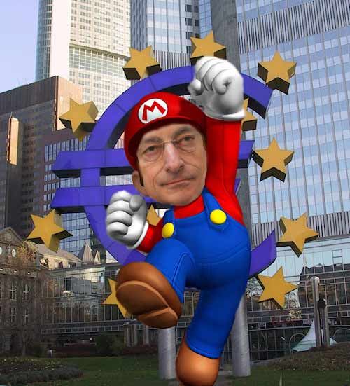
SUPER MARIO

OMT : Outright Monetary Transactions of the ECB.
Alberto Alesina, Alessandro Prati and Guido Tabellini. (1989), ‘Public Confidence and Debt Management: A Model and a Case Study of Italy’.
OMO’s: Open Market Operations

