

Women Writing Space: Representations of Gender and Space in post-1850 British Women’s Writing

7th March 2009, University of Warwick
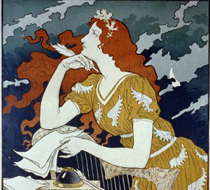

This one-day conference will explore spatial perspectives on women’s writing from a range of disciplines, reflecting the scope of contemporary feminist interest in spatial configurations. The conference will address the issue of “how British women writers represent space”, considering questions such as, how do women writers construct literary space? What types of spaces/places are represented in works by women? How are received notions of space/place interpreted, accepted, or contested? How do we theorise the textual spaces in women’s writing?

GUEST SPEAKERS:
●Rosa Ainley (London Metropolitan University)
●Lynne Walker (University of London)

This conference is organised by Arina Lungu and Charlotte Mathieson through the University of Warwick’s Humanities Research Centre. For further information and a booking form please contact Sue Dibben, HRC@warwick.ac.uk or see the conference website: http://www2.warwick.ac.uk/fac/arts/hrc/confs/wws

