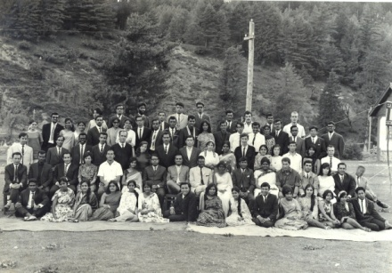

The Problem of Power

University of Warwick
6-7 October 2011

Millburn House

Accommodation Information

Rooms at the rate of £70 per night are available on-campus at Radcliffe House for the nights of October 5, 6 and 7. This rate also includes breakfast.

See http://www2.warwick.ac.uk/conferences/radcliffe/

If you would like to reserve accommodation, please contact Mrs Tracy Horton t.horton@warwick.ac.uk; 02476 572601.

Accommodation must be booked by 15 August.

Should you have any access or dietary requirements, we would be most grateful if you could please confirm at the time of request.

