Molecular tugs o'war: collaboration and competition in molecular motor teams
Rob Cross, Centre for Mechanichemical Cell Biology (r.a.cross@warwick.ac.uk)
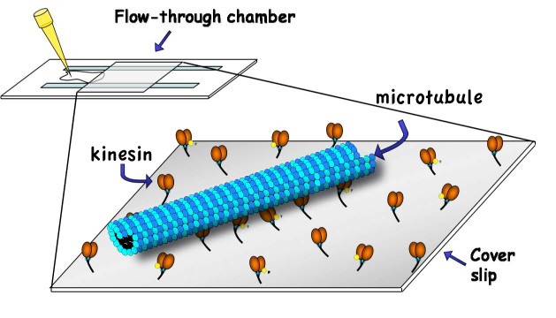
Background & concepts: Microtubule molecular motors are the dominant engines of long-range spatial self-organisation in biology, and there has been considerable recent progress on understanding their single molecule mechanisms. So far however, there has been almost no work seeking to understand the mechanisms by which multiple molecular motors join forces to generate the larger and more sustained unidirectional movements and forces seen in cells. The frontier challenge now is to discover the engineering principles and mechanisms by which the molecular mechanisms of different molecular motors interface effectively to produce concerted force and motion. The proposal is to approach this key problem in a simple model, considering an ensemble of motor automata attached to a surface at a certain spacing. These motors can attach to a track (the microtubule), which overlies the ensemble and is driven to slide across the surface at an observable velocity. Each motor-automaton has a range of behavioural options available to it. For example at any instant it can attach, detach, pause, step right or step left. The challenge is to build a mathematical description of the ensemble properties that makes concrete, testable predictions.
Research objectives: Microtubule motility assays (illustrated), in which microtubules are driven to slide by an active surface of identical molecular motors, are routine in the Cross lab and a fair amount of high quality data is available. The analysis will seek to model the collective behavior as the consequence of the interaction rules between motors attached to the same microtubule. One particular observable which can be tested against experimental data is the transport rate or velocity of the microtubule.
Wider benefit of research area: motor-driven transport is a low-level driving process in eukaryotic biology and is widely relevant. There are specific diseases that arise from defects in motorized transport (Alzheimers, Parkinsons) and drugs that inhibit motorized transport are important in cancer therapy.
Routes to a follow-up PhD: there are various routes to continue this project for PhD in theoretical and applied directions, such as mathematical descriptions and validation of non-Markovian models for motor dynamics, or simulation of emergent behavior in realistic models with comparison to data from CMCB, which could also be combined with some basic experimental work. Possible supervisors include Rob Cross, Nick Carter (CMCB), Colm Connaughton and Stefan Grosskinsky (Complexity).
References: Yajima J, Cross RA.A torque component in the kinesin-1 power stroke.Nat Chem Biol. 2005 1 :338-41.
C. Leduc, F. Ruhnow, J. Howard, S. DiezDetection of fractional steps in cargomovement by the collective operation of kinesin-1 motors PNAS USA, 104, 10847-10852 (2007)

