Visual Print Culture in Europe – techniques, genres, imagery and markets in a comparative perspective 1500-1850
Venice, December 5-6, 2015
Call for Papers

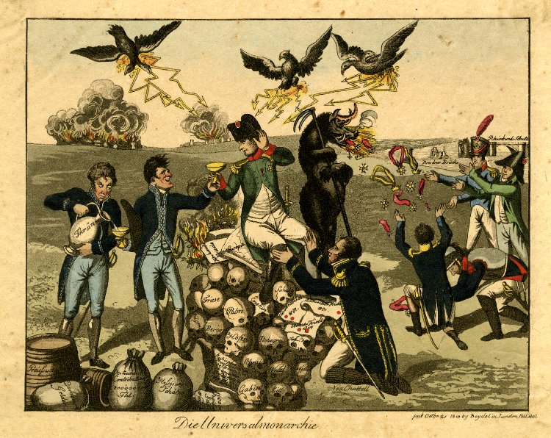
Under Napoleon’s Empire we find London acting as a hub for printing caricatures of Napoleon in a range of languages, and with a number of distinctive styles. The above print, Die Universalmonarchie, for example, claims to have been published by Boydell & Co. in London in 1815, but the Boydell’s were based at Cheapside, not – as the print states – at Pall Mall (once the location of the late Josiah Boydell’s famous Shakespeare Gallery). The publication information would seem to be spurious and the British Museum suggests that it was likely published in Paris. Is this print, then, German, French, or even possibly English? Who exactly is its market? How far is its imagery tailored to a particular “national” audience and how far might it be incomprehensible to such an audience? Besides London, what other European hubs were important, at what moments and why?
Visual Print Culture in Europe 1600-1850 aims to draw together scholars with a range of disciplinary skills to discuss the methods, representational forms, and distribution of and audience for visual print media in Europe between 1600 and 1850. Its seeks to de-nationalize the study of visual print culture, and to explore the extent to which interactions between engravers and printers, artists and consumers in Europe, and a range of common representational practices produced a genuinely European visual print culture – with local modulations, but nonetheless with a common core.
Papers can draw on a range of disciplinary backgrounds in exploring the exchange of techniques and processes, the analysis of imagery, and the identification of markets, and in analysing the conditions under which particular generic forms crossed or failed to cross national boundaries. Although the emphasis is on European visual print culture, the impact of that culture on, and its interaction with, the wider world is also of interest.
The conference language will be English.
The Conference will be held at the University of Warwick’s Palazzo and conference centre in Venice, in December 5-6, 2015.
The Conference organisers, acting under the European History Research Centre are
Kate Astbury, French Studies, Warwick
Mark Knights, History, Warwick
Mark Philp, History, EHRC Director, Warwick
David Taylor, English, Warwick
Proposals for papers should be submitted to t.smith.2@warwick.ac.uk by June 1st 2015.
The conference may be able to provide some financial assistance to those whose home institutions are unable to do so to enable their attendance.

