Talk Title

Speaker Name1

Supervisors:First Supervisor2, Second Supervisor3, Third Supervisor4

1Speaker affilitaion 1, Speaker affilitaion 2

2First Supervisor affilitaion 1, First Supervisor affilitaion 2

3Second Supervisor affilitaion 1, Second Supervisor affilitaion 2

4Third Supervisor affilitaion 1, Third Supervisor affilitaion 2

Abstract text, this should be a short outline of your research, letting people know what to expect from your talk. This should be no longer than 300 words. References can be added using the reference style shown here[1][2]. Any figures should be referred to in the text, such as Fig.1. and displayed below, with their own short caption.

Blah Blah Blah Blah Blah Blah Blah Blah Blah Blah Blah Blah Blah Blah Blah Blah Blah Blah Blah Blah Blah Blah Blah Blah Blah Blah Blah Blah Blah Blah Blah Blah Blah Blah Blah Blah Blah Blah Blah Blah Blah Blah Blah Blah Blah Blah Blah Blah Blah Blah Blah Blah Blah Blah Blah Blah Blah Blah Blah Blah Blah Blah Blah Blah Blah Blah Blah Blah Blah Blah Blah Blah Blah Blah Blah Blah Blah Blah Blah Blah Blah Blah Blah Blah Blah Blah Blah Blah Blah Blah Blah Blah Blah Blah Blah Blah Blah Blah Blah Blah Blah Blah Blah Blah Blah Blah Blah Blah Blah Blah Blah Blah Blah Blah Blah Blah Blah Blah Blah Blah Blah Blah Blah Blah Blah Blah Blah Blah Blah Blah Blah Blah Blah Blah Blah Blah Blah Blah Blah Blah Blah Blah Blah Blah Blah Blah Blah Blah Blah Blah Blah Blah Blah Blah Blah Blah Blah Blah Blah Blah Blah Blah Blah Blah Blah Blah Blah Blah Blah Blah Blah Blah Blah Blah Blah Blah Blah Blah Blah Blah Blah Blah Blah Blah Blah Blah Blah Blah Blah Blah Blah Blah Blah Blah Blah Blah Blah Blah Blah Blah Blah Blah Blah Blah Blah Blah Blah Blah Blah Blah Blah Blah Blah Blah Blah Blah Blah Blah Blah Blah Blah Blah Blah Blah Blah Blah Blah Blah Blah Blah Blah Blah Blah Blah Blah Blah Blah Blah Blah Blah Blah Blah Blah Blah Blah Blah Blah.

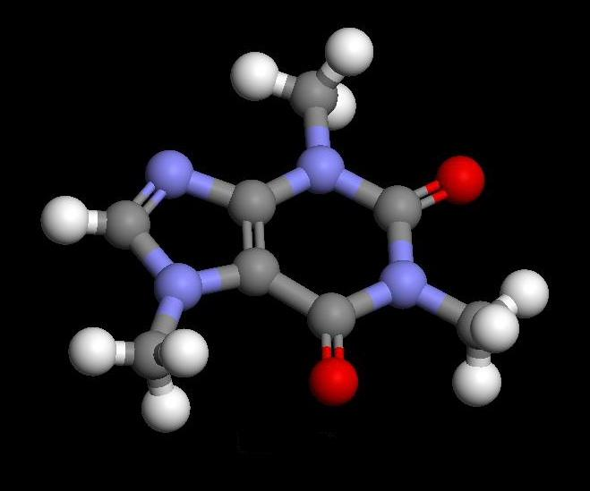

Fig.1. A short caption explaining what is shown in the figure.

[1] D.J.G.Pearce and J.W.Heal, *The Journal of Awesomeness,* 2012, **01** (01), 1234-1235.

[2] S.Y.Noh *et al., Journal of Adequacy*, 2012, **01** (01), 123-125.