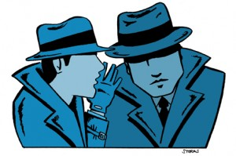
THE ETHICS OF INTELLIGENCE

11am – 5pm
6th May 2016

Interdisciplinary Ethics Research Group (www.warwick.ac.uk/ierg)
Room E2.02, Department of Politics and International Studies, University of Warwick
Contact: Francesca Melhuish (F.Melhuish.1@warwick.ac.uk) or Christopher Nathan (c.m.j.nathan@warwick.ac.uk)

Chair: Christopher Nathan (Warwick)

10:30 Arrivals/registration/coffee

11:00 'Does Intelligence Make the World Safer?'
Richard Aldrich (Warwick)

11:50 Break

12:00 'Angela Merkel’s Telephone’
Tom Sorell (Warwick)

12:50 Lunch

13:20 'Just War Theory as a Framework for Intelligence Ethics'
Kira Vrist Rønn (Copenhagen) & Adam Diderichsen (Danish National Police College)
14:10 ‘21st Century Orwells: Privacy, Transparency and the Ethics of Surveillance in Contemporary Digital Dystopias’
Simon Willmetts (Hull)
15:00 Coffee

15:10 ‘Intelligence and its Legitimacy Crisis’
Adam Diderichsen (Danish National Police College)

16:00 ‘Only Guilty People Hide: The Dark-Net and Cyber-Intelligence: Legitimating Surveillance or Legitimating Resistance’
Ross Bellaby (Sheffield)

16:50 Close

